Open Enterprise Manager

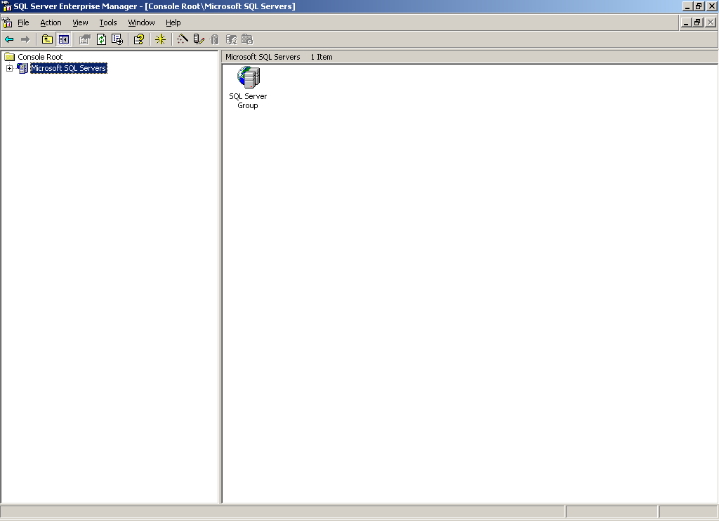

Expand the + to – till DataBase folder is coming.
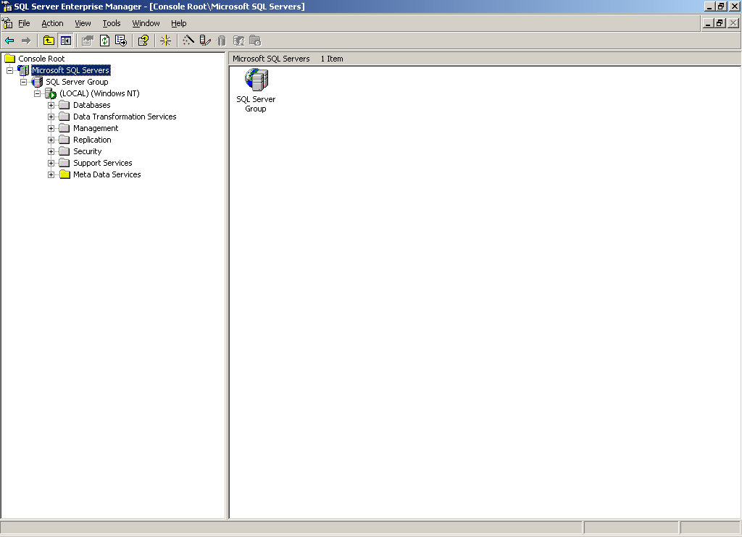
Right Click on DataBase and Click on All Task and Restore Database.

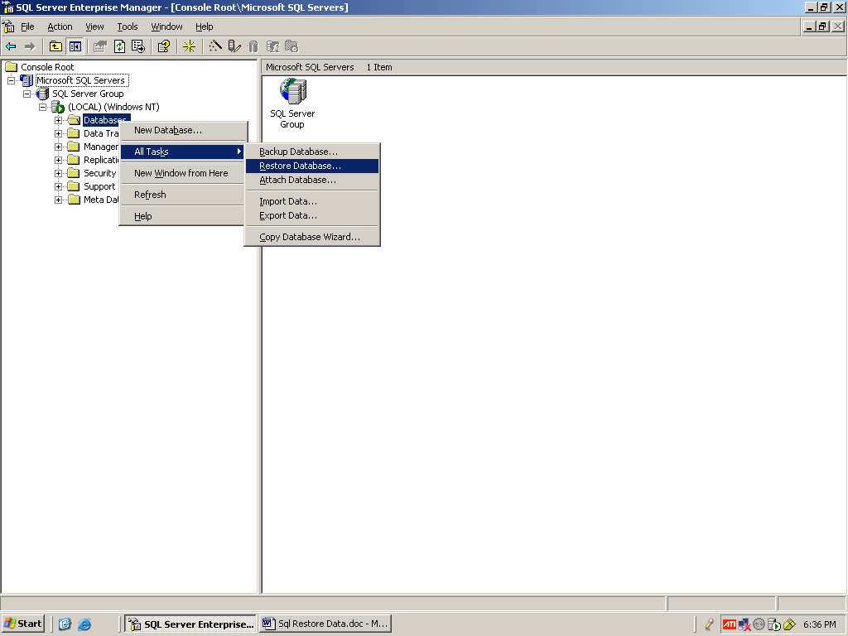

Give the Name in Restore as Database (Alerts) then Select the Form Device (Option Button). Then Click on Select Device (Button).

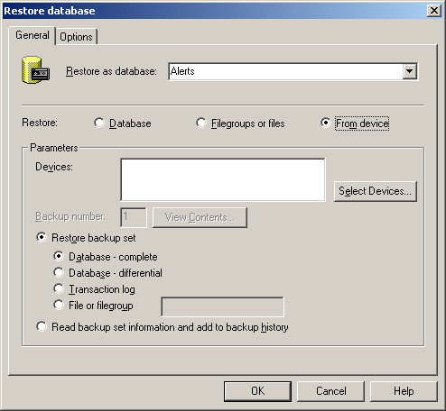
Then it will ask u to Add the File so Click the Add (Button)

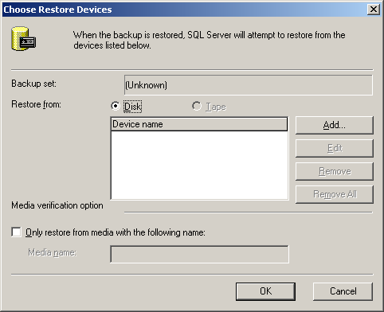

Then it will ask u to Select the file. So then click on Browse (Button).

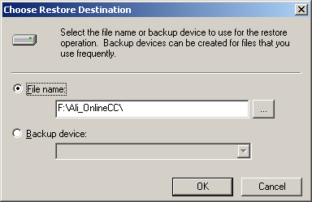

Then Select the DataBase file it will be in some Location. Then Click on Ok Button.

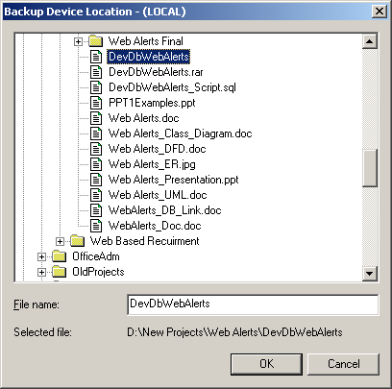

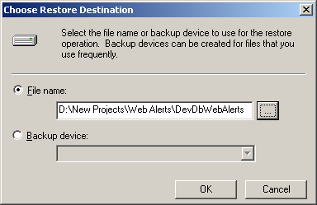

Then Click on Ok Button.

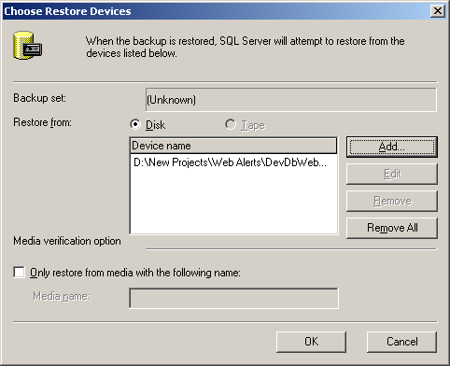

Then Click on Ok Button.

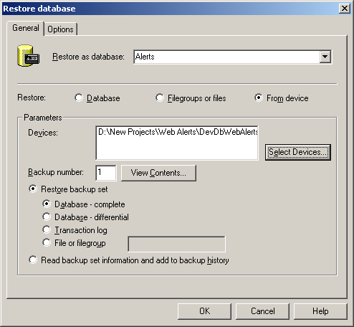

Then Click on Ok (Button).

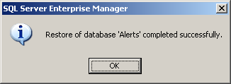

Then Click on Ok (Button).

So the Database Backup is Over it will store in the Database.

